Given the root of a binary tree, return *the inorder traversal of its nodes' values*.

**Example 1:**

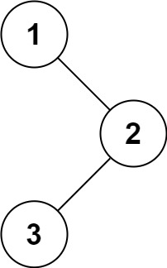

Input: root = [1,null,2,3]  
Output: [1,3,2]

**Example 2:**

Input: root = []  
Output: []

**Example 3:**

Input: root = [1]  
Output: [1]

**Constraints:**

* The number of nodes in the tree is in the range [0, 100].
* -100 <= Node.val <= 100

**Follow up:** Recursive solution is trivial, could you do it iteratively?